Practical – 8

MySQL Schema Design, ER Model, PDO Connectivity, and Prepared Statements
Problem Definition : Design the database for StudentHub with students, events and registrations. Create PHP database connection using MYSQL statements.
A. THEORY
1. Is the schema normalized properly?
Yes. The database is organized into separate tables to reduce duplicate data and keep the data consistent. Each table stores related information only.
2. Are primary keys and foreign keys correctly defined?
Yes. A primary key uniquely identifies each record in a table, while foreign keys are used to connect related tables. This helps maintain relationships between the data.
3. Is the database connection handled securely?
Yes. The database connection details are kept separate from the main application code where possible. Prepared statements and proper error handling should be used to protect the database from SQL injection and other security problems.

References
1. MySQL – Primary and Foreign Keys
2. MySQL – Database Normalization
3. PHP Manual – MySQLi Prepared Statements
4. OWASP – SQL Injection Prevention

B. Implementation/ Output/Result
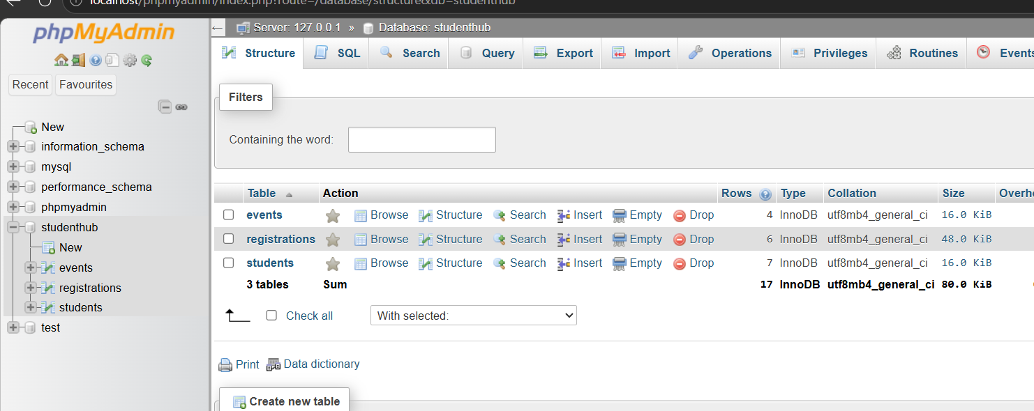

C. Evidence of Work (Screenshots)
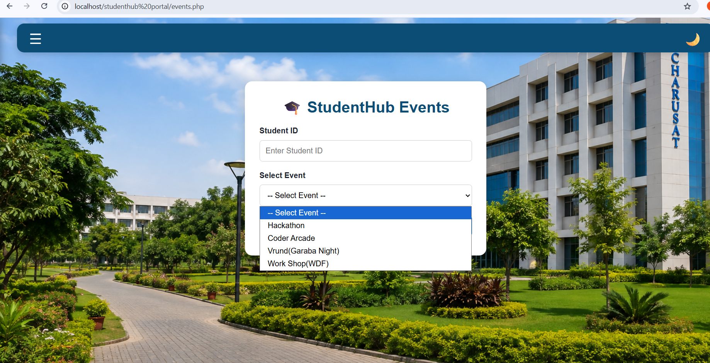


D. GitHub Repository Link
https://github.com/NencyNVagadiya/Student-Hub-portal/blob/main/events.php

E. Challenges Faced:
“I faced difficulty in designing the relationships between the Students, Events, and Registrations tables and connecting PHP with MySQL using PDO.”
F. Learning Outcomes:
Students will design and connect a normalized database securely using PHP.

G. Faculty Remarks:

